St George RTK Bases (SGU1 and SGU2)
3 September 2026
SGU1 & SGU2 Mail List Signup / Signoff: https://signup.ymlp.com/xguqjwsugmgw
Mail List Past Notices: http://ymlp.com/archive_guqjwsugjgm.php
Questions, support: Todd Jacobsen todd.jacobsen@sgcity.org 435-215-8431 mobile
Rick Snyder rick.snyder@sgcityutah.gov (435) 773-5889

2022 Information
There are two public GNSS bases in St. George available for public use at no charge: SGU1 and SGU2.
The last page of this PDF is intended as a Quick Reference for connection information. Please consider printing it out and keeping a copy in the instrument case with your GNSS Rover.
It is very difficult to keep both stations running 100.000% of the time. Configure and test both profiles in your field software to allow switching back and forth if required by station downtime.
Currently you should use GEOID18 in your data collector with both stations for new jobs.
Both stations have choke ring antennas and track GPS+GLO+GAL+BDS signals. There is very little positional difference between the stations. (Horizontal less than 10 mm, Vertical less than 5 mm.) The UHF radios are connected to SGU1, however if there is a problem with SGU1 we will move the radios to SGU2.

2026 September Update
SGU1 used to be a ProFlex 100 tracking GPS and GLO only. It is now a Trimble BD990 tracking all signals. CMR+ used to be the radio broadcast message. RTCM3.3 MSM 3 is now broadcast. Both SGU1 and SGU2 have internet connections available broadcasting RTCM3.3 MSM7. The port assignments from the previous SGU1 receiver have been duplicated on the new one.
You may need to change the Survey Profile in your receiver to accept RTCM3 instead of CMR+ when using radio backhaul.

SGU1
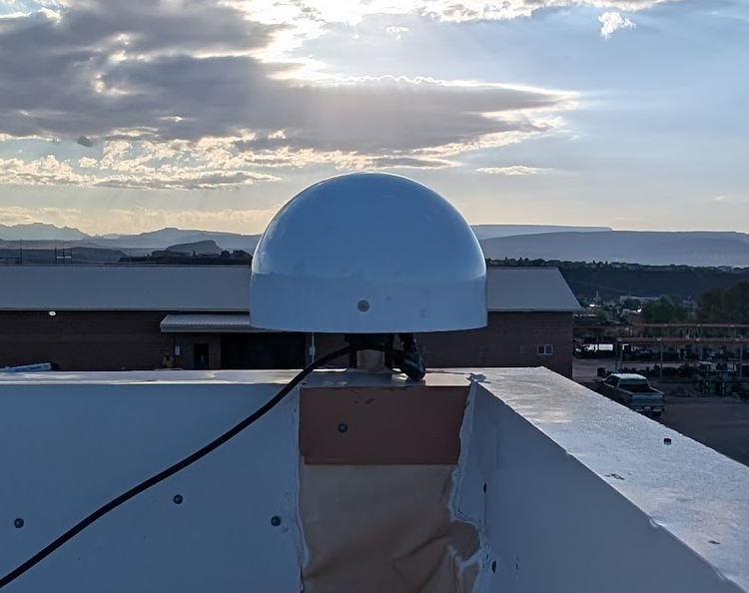
SGU1 has been in place since January 2004. The original Z-Max receiver (GPS Only) was replaced with an Ashtech PF500 (tracking GPS L1C,L1P(Y),L2P(Y); GLOANSS L1C,L2C) receiver in February 2012. In September 2026 the receiver was replaced with a fully enabled Trimble BD990 tracking GPS L1,L2E,L2C,L5; GLONASS L1C/A,L1P,L2P,L3; Galileo E1,E5A,E5B,E5AltBOC,E6; BeiDou B1,B1C,B2,B2A,B2B,B3 with a IGS absolute calibrated 3D choke-ring antenna.
SGU1 is part of the NGS CORS network:
https://geodesy.noaa.gov/CORS/ncn_station_pages/index.html?stationID=sgu1
SGU1 is available via DIP/TCPIP + NTRIP internet connection and via 3 UHF 35-Watt Base Radio, and 2 repeaters that provide coverage to most of southern Washington County:
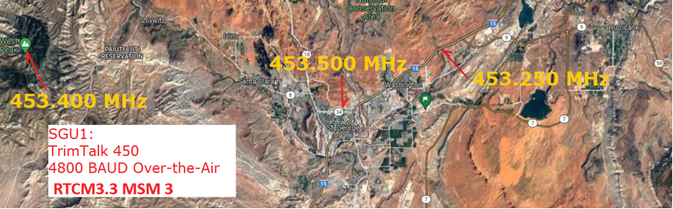
If SGU1 has issues, we will switch the radios to SGU2.
RINEX observation file archives are available from the NGS UFCORS page. Hourly 1-second interval and Daily 30-second interval RINEX3 observation files for both SGU1 and SGU2 are available from the FTP server detailed in the table below.
RINEX3 files archives are available via FTP: apis1.us, user igage, password 2337, see below.

SGU2
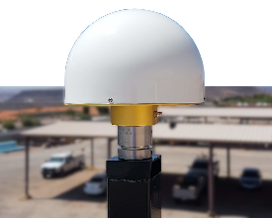
SGU2 has been in service since August 2018. This receiver is a fully enabled Trimble BD990 tracking GPS L1,L2E,L2C,L5; GLONASS L1C/A,L1P,L2P,L3; Galileo E1,E5A,E5B,E5AltBOC,E6; BeiDou B1,B1C,B2,B2A,B2B,B3 with a IGS absolute calibrated choke-ring antenna. The mount and location have been chosen to not interfere with the roof membrane and should be stable for a very long time.
SGU2 access is available only by DIP/TCPIP or NTRIP internet connection. See the last page of this document for details.
RINEX3 files archives are available via FTP: apis1.us, user igage, password 2337, see below.
Coordinates and velocity for SGU2 have been derived from averaging 664 individual 24-hour observation files through NGS OPUS-Static and using the solution average. This averaged solution has been found to match an OPUS-Projects based position within a millimeter.
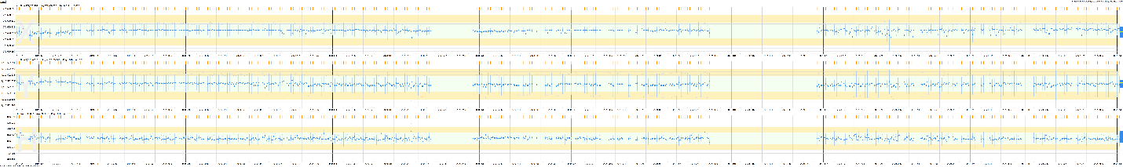

Station Details for SGU1 and SGU2
Designation | SGU1 | SGU2
Receiver Type | TRIMBLE BD990 | BD990
Receiver Serial Number | 6033C02792 | 5951C03261
Firmware Version | 5.68 | 5.63
Antenna Type | ARFAS13DFS ARFS | CHCC220GR CHCD
Antenna Serial Number | 3199603 | 13190137
RTK Broadcast Coordinates | 37 06 47.48170 N  113 34 13.02341 W  895.579 m ARP BAM  Broadcast L1 ofs  +0.11413 m => 895.693 m PC | 37 06 47.51342 N  113 34 14.00939 W  896.037 m ARP BAM  Broadcast L1 Ofs  + 0.1181 m = 896.1551 m PC
Reference Frame | NAD_83(2011)(EPOCH:2010.0000) | NAD_83(2011)(EPOCH:2010.0000)
NGS Coordinates | Booked NGS Station Coordinates  37 06 47.48130 N  113 34 13.02325 W  895.565 m ellipsoid | Average of NGS OPUS Solutions  37 06 47.513419 N  113 34 14.009385 W  896.0366 m ellipsoid
Difference between Broadcast and NGS coordinates | 2-D Horz: 0.013 m S 16 29 39 E  Vert: 0.014 m | (nil)
Velocity NAD_83 (2011) | Computed by NGS  0.0013 m/yr northward  -0.0004 m/yr eastward  -0.0012 m/yr upward | Computed via NGS OPUS solutions  0.0003 m/yr northward  -0.0008 m/yr eastward  -0.0005 m/yr upward
IP Address | 209.33.248.96 sgu1.igage.com | 209.33.248.86 sgu2.igage.com
IP DIP/TCPIP Ports  Easiest to use, no user name or password required | 7201 RTCM3.x  7202 CMR+  7203 RTCM3.x  7204 RTCM3.x  7205 RT27 1 Hz, everything | 2105 RTCM3.3 MSM7  2106 CMR+  2107 sCMRx (NOT CMRX !)  2108 RTCM3.x (legacy)  2109 RTCM27 1Hz, everything  2110 BINEX 1Hz
NTRIP Caster  Most drone and machine control tools will need an NTRIP connection instead of DIP/TCPIP. | Address 209.33.248.96  User: user  Password: user  2101 RTCM33 | Address 209.33.248.86  User: user  Password: SgU2user  2101 RTCM32  2102 CMRP  2103 sCMRx (NOT CMRx !)

RINEX Data
RINEX3 data is available for both sgu1 and sgu2 at this FTP site:
Address: apis1.us
User: igage
Password: 2337
Standard folder structure:
/rinex/yyyy/jjj/ssss /rinex/2026/244/sgu1
Standard naming structure:
ssssjjjh.yyo.zip sgu1244a.26o.zip hourly observation file with 1 second interval
ssssjjj0.yyo.zip sgu12440.260.zip daily observation file, 30-second interval

Quick Reference St George Community Reference Stations Sept 2026

UHF Radio (SGU1 with SGU2 failsafe)
Correction Protocol RTCM3.3 MSM3
Radio Protocol TrimTalk450 (TrimTalkII, TrimTalkIIe, TT450HW also may work)
Over the air baud rate 4800. (12.5 KHz Channel Bandwidth)
West (Utah Hill) 453.400 Mhz (this radio probably covers all of Washington County)
Main (center of town) 453.500 Mhz
East (Washington City) 453.250 Mhz

SGU1 DIP / TCPIP
IP Address: 209.33.248.96 sgu1.igage.com
Port: 7201 RTCM3.x MSM7 << MOST COMMON
7202 CMR+ Depreciate GPS+GLO only!
7203 RTCM3.x MSM4
7204 RTCM3.x MSM7
7205 RT27 (all signals + options + ephemeris)

SGU1 NTRIP
IP Address: 209.33.248.96 sgu1.igage.com
Port: 7207
Mountpoint: RTCM3 (RTCM3.3 MSM7)
User: user
Password: user

SGU2: DIP / TCPIP
IP Address: 209.33.248.86 sgu2.igage.com
Port: 2105 RTCM3.3 MSM7 << MOST COMMON
2106 CMR+ Depreciate GPS+GLO only!
2107 sCMRx (NOT CMRx! Not for Trimble Recvrs)
2108 RTCM3.3 MSM3
2109 DIP RT27 (all signals + options + ephemeris)

SGU2 NTRIP
User: user
Password: SgU2user
IP Address: 209.33.248.86 sgu2.igage.com
Port: 2101 RTCM3.3 MSM7 << MOST COMMON
2102 CMR+
2103 sCMRx

