OGD1

CORS station at Kapp in Ogden Utah

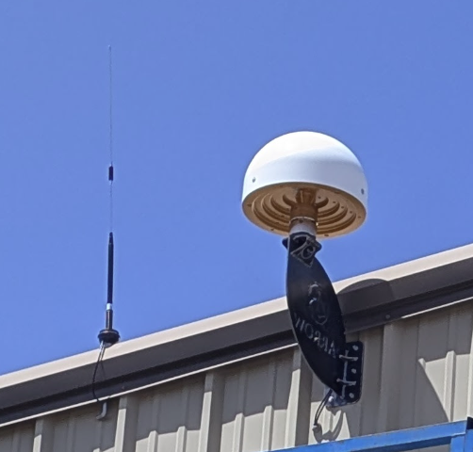

Connection notes:

DIP / TCP Address: apis1.us Port: 2105 RTCM32 MSM7

DIP/ TCP Address: apis1.us Port: 2104 RT27

NTRIP Address: apis1.us, Port 2101, User igage, Password 2337  
 Mountpoint: OGD1_RTCM3

Broadcasts: Satel 3AS, 9600 baud, FEC OFF, RTCM33 MSM7

## Receiver

## Antenna

ARFAS13DFS ARFS TYPE / SERIAL NO

ROBOT Geo++ GmbH 5 05-DEC-18 METH / BY / # / DATE

5.0 DAZI

0.0 90.0 5.0 ZEN1 / ZEN2 / DZEN

4 # OF FREQUENCIES

IGS20_2233 SINEX CODE

# Number of Calibrated Antennas GPS: 005 COMMENT

# Number of Individual Calibrations GPS: 012 COMMENT

# Number of Calibrated Antennas GLO: 005 COMMENT

# Number of Individual Calibrations GLO: 012 COMMENT

# GLONASS PCV (metric) COMMENT

# derived from Delta PCV per 25.0 MHz COMMENT

# for frequency channel number k=0 COMMENT

G01 START OF FREQUENCY

+0.47 -0.17 **+114.13** NORTH / EAST / UP

## TURN Position

Using TURN with Null Antenna and no offsets:

41 12 16.23455 N 112 01 07.01412 W; 1319.699 M Ellipsoid Height

## Initial OPUS Project Result

Files are in this folder: ./position/20250613

OPUS EL HGT: 1319.589 m 0.017 m  
 **1319.703**

SessionA EL HGT: 1319.592 m 0.004 m

SessionB EL HGT: 1319.588 m 0.005 m

Use this one:

Mark’s Final 3D EL HGT: 1319.599 m 0.003 m  
 1319.599 + 0.114 = **1319.713**

The difference between TURN and the final 3D adjustment is 0.014 cm (0.046 feet). When the receiver was running as a TURN rover, the elevation was bouncing around more than a tenth of a foot, so TURN may match an OPUS Project solution.

Broadcast Position: June 16, 2025

From 24-hour OPUS solution:

SOFTWARE: page5 2008.25 master297.pl 160321 START: 2025/06/14 00:00:00

EPHEMERIS: igu23706.eph [ultra-rapid] STOP: 2025/06/14 23:59:30

NAV FILE: brdc1650.25n OBS USED: 59763 / 61278 : 98%

ANT NAME: ARFAS13DFS ARFS # FIXED AMB: 239 / 258 : 93%

ARP HEIGHT: 0.00000 OVERALL RMS: 0.013(m)

REF FRAME: NAD_83(2011)(EPOCH:2010.0000) ITRF2020 (EPOCH:2025.4507)

X: -1802051.704(m) 0.001(m) -1802052.731(m) 0.001(m)

Y: -4456065.675(m) 0.001(m) -4456064.391(m) 0.001(m)

Z: 4180406.796(m) 0.001(m) 4180406.654(m) 0.001(m)

LAT: **41 12 16.23434** 0.001(m) 41 12 16.24806 0.001(m)

E LON: 247 58 52.98539 0.001(m) 247 58 52.92386 0.001(m)

W LON: **112 1 7.01461** 0.001(m) 112 1 7.07614 0.001(m)

EL HGT: 1319.577(m) 0.001(m) 1318.878(m) 0.001(m)

ORTHO HGT: 1336.467(m) 0.040(m) [NAVD88 (Computed using GEOID18)]

1319.577 + 0.114 = **1319.691**