42U2
Installation Date: 7/14/2025
Coordinates Valid: 7/15/2025 09:13 MDT
More information: https://igage.com/out/CORS/42U2_MorganUT/index.htm

Connecting
Direct Connection: may be faster, has less connection glue
Address Port Type Message
apis1.us 2006 DIP RTCM3.3 MSM4
apis1.us 2007 NTRIP RTCM3.3 MSM4 user: user password: user

Brokered Connection: goes through the iGage ntrip caster
Address Port Type Message
apis1.us 2101 NTRIP RTCM3.3 MSM4 user: igage password: 2337

Radio: not currently available by UHF radio

Static Data
Full constellation 1Hz, files are available by FTP:
Address: apis1.us
User: igage
Password: 2337
1Hz Rinex: Look in /rinex
Daily Files (30 second, GPS only): Look in /dailys/42u2
Daily OPUS files for trending: /opus/42u2

OPUS Solution
USER: mark@igage.com DATE: July 15, 2025
RINEX FILE: 42u2196a.25o TIME: 14:57:02 UTC

SOFTWARE: page5 2008.25 master271.pl 160321 START: 2025/07/15 00:00:00
EPHEMERIS: igu23752.eph [ultra-rapid] STOP: 2025/07/15 11:00:00
NAV FILE: brdc1960.25n OBS USED: 29897 / 31093 : 96%
ANT NAME: ARFAS13DFS ARFS # FIXED AMB: 124 / 127 : 98%
ARP HEIGHT: 0.0001 OVERALL RMS: 0.012(m)

REF FRAME: NAD_83(2011)(EPOCH:2010.0000) ITRF2020 (EPOCH:2025.5349)
X: -1779851.201(m) 0.005(m) -1779852.216(m) 0.005(m)
Y: -4477566.355(m) 0.004(m) -4477565.071(m) 0.004(m)
Z: 4167340.759(m) 0.005(m) 4167340.617(m) 0.005(m)
LAT: 41 2 47.98536 0.005(m) 41 2 47.99929 0.005(m)
E LON: 248 19 19.10600 0.006(m) 248 19 19.04534 0.006(m)
W LON: 111 40 40.89400 0.006(m) 111 40 40.95466 0.006(m)
EL HGT: 1534.970(m) 0.002(m) 1534.260(m) 0.002(m)
ORTHO HGT: 1551.135(m) 0.051(m) [NAVD88 (Computed using GEOID18)]

Ellipsoid Height: 1534.970
L1 Phase Center Offset: 0.11413
Phase Center: 1535.0841

Reference Station Configuration
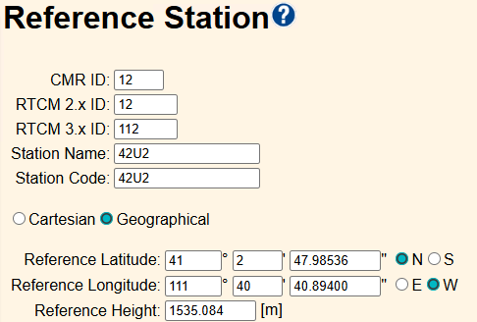

Tracking
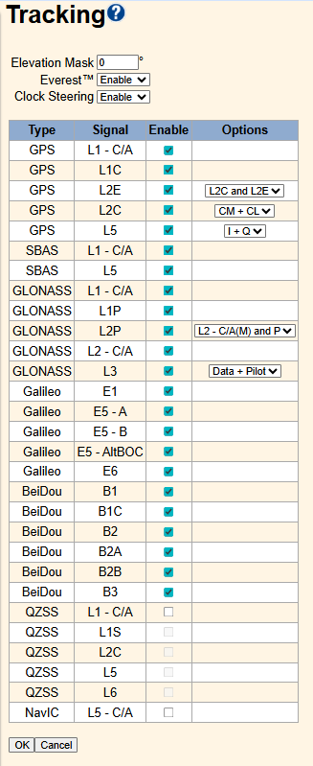

Antenna Configuration
